
Strategic Review

Consultation Document
  - August 2024

Introduction
NILGOSC is the administering body for the Local Government Pension Scheme (LGPS) in Northern Ireland. Its role is primarily to administer the LGPS Regulations, both in terms of pension scheme administration, including the calculation and payment of benefits, and management of the investment fund. The Regulations are made by the Department for Communities and, while NILGOSC responds actively to any consultation process, it does not have any power to change the regulations or determine their content. In this respect, NILGOSC’s role is relatively constrained with its function being to deliver a pension service to scheme members and employing authorities in accordance with the regulations. Within this narrowly defined function, the focus continues to be on providing a high-quality service to all stakeholders, in line with continually evolving expectations.
Like most organisations, NILGOSC has established a strategic planning process which allows it to identify and achieve its long-term strategic objectives. A key part of this process is the triennial strategic review, during which the organisation’s vision, mission, values and strategic aims are subjected to a thorough review and stakeholder consultation to ensure that they remain relevant and reflective of the current operating environment. In the intervening period between strategic reviews, NILGOSC reviews and updates its operational business plans annually to help plan resources and measure performance.

Why we are consulting
NILGOSC commenced its latest strategic review with a strategic planning workshop held on 22 May 2024. This workshop provided the Management Committee with an opportunity to assess the current operating environment and to inform the strategic direction of the organisation for the next three years. A Stakeholder Analysis was completed to identify current stakeholders and their needs and expectations while a SWOT analysis was also undertaken to identify and examine NILGOSC’s strengths and weaknesses, opportunities and threats. The output from this analysis formed the basis of the strategic framework set out in this document, which will drive service delivery over the next three years.
As a key stakeholder, NILGOSC is seeking your views on its Vision, Mission, Values and Strategic Aims and Objectives.

How you can contribute
NILGOSC welcomes views on its strategic framework and this consultation sets out a series of questions on each of the strategic components. You can respond to these specific questions or free-form responses are also welcome. Please tell us who you are or which group or organisation you are representing in order that we can better understand the context of your response.
The consultation is open for 8 weeks and any comments should be submitted prior to the closing date of 1 November 2024. You may write to us using the details below or via email at governance@nilgosc.org.uk. We look forward to hearing from you.
The consultation documents can be made available in alternative formats such as large print, computer disk, Braille, audio tape and languages other than English. If you would like the document in an alternative format please contact the Equality Officer using the details below:
Post: Templeton House, 411 Holywood Road, Belfast BT4 2LP
Telephone: (0345) 319 7320
Fax: (0345) 319 7321
Typetalk: 18001 0345 319 7320
Email: equality@nilgosc.org.uk

NILGOSC will publish a summary of all responses received following completion of the consultation process. All responses to this consultation will be subject to the Freedom of Information Act 2000, which gives a right of access to information held by public authorities. Before you submit your response, please read Appendix 1 about the effect of the Freedom of Information Act 2000 on the confidentiality of responses to public consultation exercises.
A screening exercise was undertaken on the draft Vision, Mission, Strategic Aims and Values to determine if an Equality Impact Assessment is necessary. The outcome of this screening exercise was not to conduct an Equality Impact Assessment and the full screening report is available on request.

Strategic Backdrop
NILGOSC has identified seven overarching themes and drivers for its strategic planning and decision making. These themes are displayed in the graphic below:
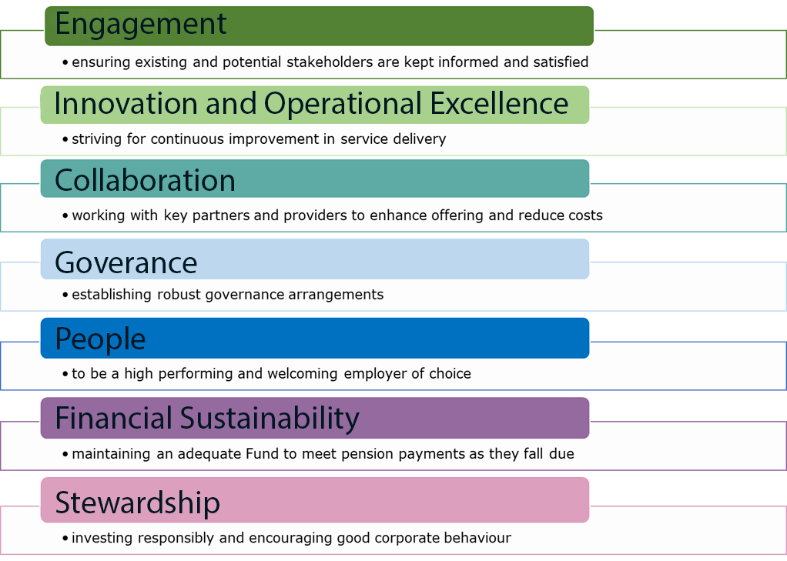
As a pension scheme, a key part of NILGOSC’s strategic decision making relates to the Investment Strategy, which sets out how the Fund is invested. The overriding objective is to invest prudently so as to ensure that the benefits promised to members are provided and to provide reasonable stability in contribution rates for the employers. The Investment Strategy is long term in nature and takes account of the nature and timing of the Fund’s liabilities identified through the triennial actuarial valuation and its funding objective. NILGOSC’s current funding and cashflow position allows it to continue to pursue investment opportunities that generate an attractive rate of return within lower risk parameters. Given its significance, NILGOSC undertakes a separate formal review of its Investment Strategy every three years, taking into account the professional advice of its Investment Advisor and Scheme Actuary. The latest review commenced in June 2024 and will culminate in the determination of a suitable investment strategy and performance objective.
Scheme affordability remains a top priority and the current backdrop of higher interest rates and sticky global inflation, together with public sector financial constraint, continues to provide a number of challenges in respect of funding, membership and employer finances. The next valuation of the Fund will be carried out at 31 March 2025 and this will give an important snapshot of scheme demographics and funding.
NILGOSC’s stakeholder base has remained broadly unchanged over time and key stakeholders, namely scheme members and employers, remain the primary focus from a service delivery perspective. Technology continues to advance and electronic communications now play an integral role in NILGOSC’s service delivery strategy, subject always to member preference. The online member portal offers those members who choose to use it 24/7 access to their pension record, together with the ability to update changes and run multiple projections of their retirement benefits. From an employer perspective, automation of the exchange of member payroll data is an ongoing project, with many employers already onboarded and seeing the benefit of straight through processing. Both systems are designed to improve data accuracy and ultimately the timeliness of service delivery to members. Stakeholder satisfaction remains a key performance indicator and care continues to be taken to ensure that self-service functionality is not to the detriment of meaningful communication and engagement with members.

Communication forms a fundamental part of NILGOSC’s strategic plan as it seeks to ensure that members and employers understand and engage with their pension scheme. This in itself is not without challenge as pension scheme complexity increases with each passing set of regulations, together with the wider taxation and legislative backdrop. In recent times amending McCloud Regulations and changes to the pension taxation regime have proved an additional challenge to stakeholder understanding and overall administrative efficiency. To help address this, NILGOSC continues to engage with decision makers to influence and inform the local government pension scheme of the future. As a public body, accountability is paramount and NILGOSC continues to seek to be ‘best in class’ from both a pension service perspective and from a governance perspective.
It is within this context that NILGOSC presents its Vision, Mission, Values and Strategic Aims and Objectives for consultation.

Consultation Questions

Vision, Mission and Values
NILGOSC’s vision is: To provide an excellent and sustainable pension scheme.
Question 1: Do you agree with our vision? If not, what would you expect to see included?
NILGOSC’s mission statement is: To operate the pension scheme efficiently, effectively and sustainably while enhancing the quality of service provided to stakeholders.
Question 2: Do you agree with our mission statement? If not, what would you expect to see included?

In carrying out its aims and objectives NILGOSC is committed to the following nine values:
- member focused service delivery.
- maximising returns within acceptable risk parameters.
- sustainability, both as an investor and as a pension scheme.
- responsiveness, taking action in a timely manner.
- operational excellence through innovation.
- collaboration to achieve shared goals.
- fairness, embracing equality and diversity in its widest sense.
- honesty, integrity and openness in our engagement with stakeholders.
- being understandable, providing simple, clear and complete information.
Question 3: Do our values meet your expectations for a public sector pension scheme? If not, what would you expect to see included?

Strategic Aims and Objectives
NILGOSC has six strategic aims which set out what it wants to achieve. Beneath each aim sits a number of objectives, which set out what NILGOSC plans to do to achieve them.

Strategic Aim 1: To provide an effective service complying with the pension scheme regulations, good practice, other legislation and stakeholder expectations.

Objectives
- To pay members’ pension benefits, refunds and transfers promptly and accurately.
- To credit pension contributions, transfers and other employer liabilities received promptly and accurately.
- To provide members with information needed to make pension decisions promptly.
- To pay death benefits promptly and accurately.
- To ensure that all necessary action is taken on any change to scheme rules.
- To ensure that systems and procedures comply with relevant legislation.
- To maintain accurate and complete member data.

Strategic Aim 2: To deliver an effective investment strategy in line with the actuarial profile of the fund.

Objectives
- To value the scheme assets and liabilities and set contribution rates accordingly.
- To invest scheme funds in accordance with the Statement of Investment Principles.
- To deliver investment performance within appropriate risk return parameters.
- To review investment performance regularly.
- To ensure effective stewardship in line with responsible investment policy.

- To manage the investment risks posed by climate change.
- To understand and adopt good practice in Public Sector pension fund management.
- To work collaboratively on investment matters when suitable opportunities arise.

Strategic Aim 3: To promote the scheme and inform members and employers of their pension options.

Objectives
- To actively encourage retention in, and new membership of, the Scheme.
- To provide general scheme information to scheme employers, their employees, members, Trade Unions and pensioners through active engagement.
- To provide members and employers with specific details of Regulation changes and relevant tax legislation changes.

Strategic Aim 4: To influence and inform the debate on the future of the Local Government Pension Scheme

Objectives
- To influence changes to the LGPS and actively contribute to relevant consultations.
- To engage with, and inform, interested parties and relevant decision makers.
- To improve the Scheme Regulations for the benefit of employers and members.

Strategic Aim 5: To undertake business in an efficient, effective and accountable manner as required of a public body.

Objectives
- To enhance corporate governance arrangements appropriate for a public body.
- To maximise efficiency through the use of technology.
- To manage change in an effective and timely manner.

- To ensure NILGOSC attracts and retains well trained personnel
- To ensure that the office environment meets the growing needs of stakeholders and staff
- To ensure an effective and cohesive Committee

Strategic Aim 6: To promote equality of opportunity, good relations and to fulfil Section 75 obligations.

Objectives
- To assess the likely impact of policies on the promotion of equality of opportunity and good relations.
- To ensure NILGOSC personnel policies promote equality of opportunity.
- To ensure that NILGOSC meets or exceeds best practice as set out by the Equality Commission.
Question 4: Do our strategic aims meet your expectations for a public sector pension scheme? If not, why?

Question 5: Is there anything else you would expect to see included in our strategic aims and objectives?

Question 6: Have you any other comments on our Vision, Mission, Values, Strategic Aims and Objectives?

Appendix 1

Freedom of Information Act 2000 – Confidentiality of Consultations
NILGOSC will publish a summary of responses following completion of the consultation process. Your response, and all other responses to the consultation, may be disclosed on request. NILGOSC can only refuse to disclose information in exceptional circumstances. Before you submit your response, please read the paragraphs below on the confidentiality of consultations and they will give you guidance on the legal position regarding any information given by you in response to this consultation.
The Freedom of Information Act gives the public a right of access to any information held by a public authority, namely NILGOSC in this case. This right of access to information includes information provided in response to a consultation. NILGOSC cannot automatically consider as confidential information supplied to it in response to a consultation. However, it does have the responsibility to decide whether any information provided by you in response to this consultation, including information about your identity should be made public or be treated as confidential. This means that information provided by you in response to the consultation is unlikely to be treated as confidential, except in very particular circumstances.
The Lord Chancellor’s Code of Practice on the Freedom of Information Act provides that:
- NILGOSC should only accept information from third parties in confidence if it is necessary to obtain that information in connection with the exercise of any of its functions and it would not otherwise be provided;
- NILGOSC should not agree to hold information received from third parties “in confidence” which is not confidential in nature;
- acceptance by NILGOSC of confidentiality provisions must be for good reasons, capable of being justified to the Information Commissioner.
For further information about confidentiality of responses please contact the Information Commissioner’s Office (or see website at: https://ico.org.uk).

